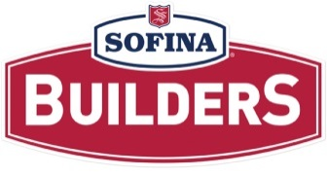
Career Growth Opportunity

DATE: September 13, 2022

LOCATION: Belleville Plant

JOB: Grinding Associate

SHIFT: Day Shift – 5:30 am start time

AREA: Grinding

We currently have one (1) opening for the position of Grinding Associate

Main Duties:
- Responsible for operating mixer, bowl chop, grinders, and dicer/blanchers
- Assemble/disassemble machinery
- Receive meat, retrieve and weigh raw product-monitoring FIFO- records weights and lot numbers
- Prepare spices to complete mixes, verifying and recording lot numbers and weights
- Documentation of nitrite usage on the nitrite checklist
- Completion of the CCP paperwork for the weighing and addition of nitrite
- Complete pre-op checklist
- Lift frozen product onto conveyor
- Monitor temperatures and complete checklist
- Weigh and record weights of product per yield reporting requirement
- Execution of all job functions shall be done in accordance to Quality and Food Safety procedures
- Works in accordance with all Health & Safety Regulations

Requirements:
- Grade 12 or equivalent
- Excellent organization and attention to detail
- Ability to follow and execute instructions given by managers/supervisors

How to Apply?

- If you are interested in applying for this position, please send your resume to mhurd@sofinafoods.com

