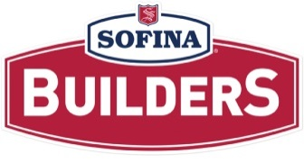
Career Growth Opportunity

DATE: September 14, 2022

LOCATION: Belleville Plant

JOB: Packaging and RTE Associate

SHIFT: Day Shift – 6:00 am start time

AREA: Packaging and RTE

We currently have one (1) opening for the position of Packaging and RTE Associate

Main Duties:
- Verify lot # and WIP codes on hangers/carts before process
- Visually inspect product to ensure it meets criteria
- Cut ends from product
- Bag product and vacuum seal
- Ensure product successfully goes through metal detector
- Label product ensuring proper packaging material and best before date
- Weigh product, apply sticker
- Box and palletize the product
- Execution of all job functions shall be done in accordance to Quality and Food Safety procedures
- Works in accordance with all Health & Safety Regulations

Requirements:

- Grade 12 or equivalent
- Excellent organization and attention to detail
- Ability to follow and execute instructions given by managers/supervisors

How to Apply?

- If you are interested in applying for this position, please send your resume to mhurd@sofinafoods.com

